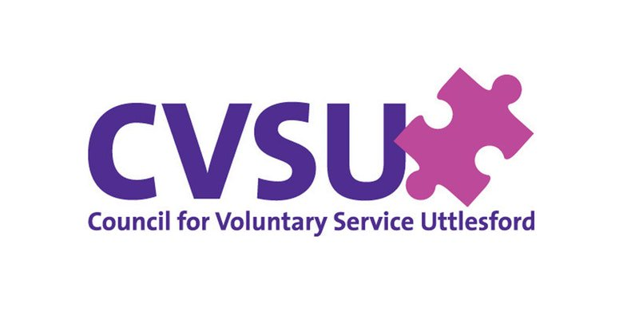
Free Training course for anyone interested in Developing Projects in their Community
What is asset based community development - ABCD?
Asset based community development (ABCD) is a localised and bottom-up way of strengthening communities through recognising, identifying and harnessing existing 'assets' (i.e. things like skills, knowledge, capacity, resources, experience or enthusiasm) that individuals and communities have which can help to strengthen and improve things locally.
Instead of looking at what a community needs or lacks, the approach focuses on utilising the 'assets' that are already there.
The approach facilitates the empowerment of individuals and communities by helping them to identify and share their strengths and then work together to create their own social innovations.
ACT NOW to find out how you can create a safer, healthier, more, economically and environmentally vibrant place for you, your family and your neighbours to live.
HOW TO ENROL?
The second course will start online on 23rd February 2021. It will cover 8 sessions. Each session lasting 90 minutes. Every participant will be issued with a Certificate of Attendance upon completion as well as access to resources.
For more information, please contact the Community Responder CVSU on christine.chester@cvsu.org.uk or call 07841 632 085. Places are limited so please sign up as soon as possible.
Closing date is 30th January 2021
To enrol go to https://forms.gle/wrdEXEuVWqFHPeWK8

Uttlesford Response, Recover, Sustain Project is funded by

